Reading 10-1: How to Set Up a Budgeting and Planning System by Robert N. West and Amy M. Snyder

Two years ago, Penn Fuel Gas, Inc. (PFG) initiated its first annual and long-range operating budget process. PFG is a public utility holding company with consolidated revenues of $125 million and 550 employees. In addition to selling natural gas, the company provides natural gas storage and transportation services, provides merchandise services, and has a propane business. PFG’s utility operations are split between two subsidiaries, each with a number of locations.

The motivation for budgeting came jointly from PFG’s bankers, its board of directors, and its management. The information needs of all three users were fairly similar. All three were interested in cash flow projections and future earnings potential. The board was interested in improving PFG’s return on equity (ROE), and it wanted to analyze the prospects of reinstituting a common stock dividend. In addition, management wanted segment P&Ls and improved departmental (cost center) expense and cash flow tracking. PFG’s segments are regions, lines of business (utility, propane, and merchandise, and type of customer commercial, industrial, residential).
WHERE TO START?
The first decision was whether to use existing in-house personnel, hire consultants, or hire a full-time budget manager. Consultants or a new hire would offer the benefit of an independent, fresh perspective with no biases. The disadvantage is that they wouldn’t know the business as well as an insider. Penn Fuel Gas used consultants to set up its first budget and then hired a full-time, experienced professional to handle its budgeting. PFG wisely gave the position a manager title to assign appropriate status to the position. Once the staffing decision was resolved, the new budget director faced three primary tasks.

Learn the business. PFG hired a self-directed person (co-author Amy Snyder) who could understand the business quickly and get both long-range and operating budget processes up and running. Although the operations of PFG’s business are relatively straightforward, the rules and regulations of the public utility industry are complex. PFG did two things to bring the budget manager up to speed. It sent her to a week-long technical program to learn the regulatory side of the business, and it extended her an open invitation to important meetings of operations vice presidents and top management so she could learn the operating side of the business.
Budgeting for natural gas and propane operations is difficult because a significant amount of demand for these products is dependent upon Mother Nature. Penn Fuel experienced two abnormal winters in its first two years of budgeting. In 1994, Pennsylvania had its coldest, iciest winter in history; in 1995, it had one of its warmest. But forecasting is difficult for many rapidly growing companies (one group for whom this article is intended). They must be flexible. For example, PFG prepares budgets using the normal weather forecast, but it also provides sensitivity analyses and budget reprojections at least quarterly. Company and budget personnel realize that capital spending is partially a function of the winter season’s revenues, which won’t be known until the first quarter is over. The first quarter is particularly important in the utility and propane business as it represents 40% of total annual product delivered.
Determine the users’ information needs. Different users have different information needs, and users don’t always know what information they “need.” If managers or board members are not financially oriented, as is the case with many small businesses, they may need a little guidance. PFG’s directors included several financially astute individuals who had a clear
idea of what information they wanted. Costs were budgeted on both an accrual basis (for P&L reports) and cash basis (for cash flow reports).
Review and update the information system.
All accounting information systems (AIS) face the daunting task of trying to provide the appropriate output for multiple sets of users. The reports needed from Penn Fuel’s MS included:

1. External financial reports (GAAP), 2. Tax reporting, 3. Internal management segment reports, 4. Cash flow reports, and 5. Reports for regulators.
The budget manager analyzed the AI to determine whether data were classified and summarized in a manner useful for internal business plans and budget reports. Most accounting systems are geared toward external financial reports, and, in the case of regulated industries, for reports to regulators as well. Internal managers usually prefer information provided in a different format, such as results by division, product line, region, or customer group.
DECISIONS TO MAKE
PFG’s budget manager faced some interesting information systems setups on which she had to make decisions when she started her work.
Different internal reporting systems. The Northern division, acquired several years ago, reported its results in different formats from the Southern division. Eventually a common reporting system will be attained, but the immediate task was to rearrange the data to assist with the consolidation and make the division data comparable. The underlying information systems differed as well. The two divisions used different accounting software, adding another challenge to the eventual merging of information systems.
Treatment of a different business segment. PFG’s propane business segment seems similar to the natural gas business, but it has several key
differences. Because it is unregulated, it has direct control over the pricing of its product. The utility’s chart of accounts was not a perfect fit. PFG had to decide whether to maintain a uniform chart of accounts or create a separate general ledger account structure for its propane business segment. PFG adapted the propane business unit’s account structure to the utility account structure. The tradeoff was ease of corporate reporting versus the individual business unit’s desired view of the data. A slight edge was given to corporate reporting.
Management and the board of directors wanted segment information that was difficult to obtain. Total spending and spending by operating unit were easy to retrieve, but other views of the information had not been developed. For example, segregating operating expenses by business segment was pro-vided partially by existing reports, but aggregation of all segments was tedious to reconcile to the general ledger due to corporate staff allocations. Most corporate personnel, from the president down to the fixed asset accountants, do not keep formal track of their time. Allocations were made to the various business segments on spreadsheets, requiring an audit trail and explanations to reconcile back to the results per the accounting records.
Review expense classifications. As a company grows, its chart of accounts should be reviewed periodically to determine if information is being captured in the most meaningful way. Introducing a budget system is an ideal time to modify the accounting system with a view toward future information needs. PFG’s new budget manager reviewed the utility’s accounting system with a fresh perspective and came up with a couple of suggestions to improve the precision of the accounting information system.

The first suggestion was to get rid of miscellaneous expense accounts with large balances. Most businesses prefer that almost nothing be recorded in miscellaneous accounts. PFG’s state-mandated chart of accounts lent itself to this practice as the chart of accounts included many miscellaneous expense accounts.
The challenge here was two-fold:

1. Perform an account analysis to reclassify some of the charges to the miscellaneous expense account, and 2. Change the accounting system (add accounts and subaccounts) to ensure that future transactions are put into more descriptive accounts.

Lack of sufficient detail, such as the overuse of miscellaneous expense, is a common small business practice, so many new budget managers will face a housekeeping task similar to PFG’s.

The next suggestion was to change the expense classification system. For example, the training & education account included charges for the training course fee, hotel, travel, meals, and the salary charge for the time at the training session, and so on. This system actually was an activitybased costing system in which training included all costs driven by the decision to send an employee to a training program. While this classification of costs is perfectly acceptable, some accountants would record these items in separate accounts to maintain more detail. PFG has several hundred active general ledger accounts, so transaction classification is not a trivial task.

Most companies initiating a budgeting and planning function should review thoroughly the chart of accounts, account classification (particularly expenses), and the reporting system. In many cases, the accounting system will not have kept pace with the changes in the company (for example, expanded product lines or changes in customers and geographical regions served. It is best if the budget manager resolves information classification and reporting issues up front so that future budgets are comparable. It is difficult to change a system once it has been developed, and budget systems are no different from any other information system in that respect.
Difficulty reconciling amounts back to the ledger. Using the example of training costs cited above, some salary costs were included in accounts other than salary expense. Reconciling
accounts such as salaries between the ledger and the payroll register can be difficult. Other accounts are difficult to reconcile as well. The budget manager decided to reclassify some data, but verifying the accuracy of reclassified data was, and still is, a challenge.
Information timeliness/availability. Budgeting brought the desire for better and faster information. PFG uses a minicomputerbased accounting package for general ledger, human resources, and payables. Yet portions of the accounting system still are manual, and monthly closings can take up to three weeks. PFG responded to some of its information needs by installing a new billing system that computerizes cash receipts and provides excellent summary information. PFG also is looking into a computerized project tracking system (for its many construction projects) and improving the computerized fixed assets system by adding a budget feature.
DELIVERABLES
Management wanted a one-year business plan prior to year-end as well as monthly updates (for example, budget vs. actual results). In addition, the board of directors wanted a long-range (three-year) plan each year. To meet these needs, the budget manager developed packets for the directors and management.
The board wanted the financial and operational data reported by segment—some reports segmented geographically, some by product line, and others by customer type.
The monthly financial packet. The monthly financial packet includes the following schedules:

- P&L and cash flow (by region and in total) 1. Current month a. Actual vs. budget b. Actual vs. same month in prior year 2. Year-to-date (YTD) a. YTD actual vs. YTD budget b. Budget projections for remainder of year c. YTD actual vs. prior YTD actual
3. Two full-year monthly bar charts a. Actual vs. budgeted cash flow b. Actual vs. budgeted net income 4. Capital structure and ROE
B. Selected five-year comparative data
1. Current month and YTD units of product delivered a. Residential b. Commercial c. Industrial d. Resale e. Detail provided for 10 largest customers 2. Gas and propane stored 3. Comparative YTD income statements
The annual business plan. The annual business plan contains data similar to the monthly package by region and in total. Full-year budget data are compared with the current year estimated (10 months’ actual plus estimates for November and December) results and prior year actual results. These data are shown in tabular and graphical form. The annual plan also contains:
A. Budgeted income statements for all 12 months. B. Budgeted cash flow statements for all 12 months. C. Budgeted ROE schedule for all 12 months. D. Capital expenditures forecasts, including brief written descriptions of the projects, by segment. 1. New business (line extensions) 2. Replacements/betterments 3. Meters 4. Tools & equipment F. Personnel data including projected new hiring, replacement hiring, and workforce reductions.

Explanations of significant variances from prior year actual results are provided in both the annual and monthly packages. Second-stage variance analysis (breaking the variance into its price and quantity components) is provided as needed.

Formatting tips. After completing the first budgeting exercises, the budget manager came to the conclusion that some formatting tips might help those persons who were not familiar with the budgeting process. First, she suggests using graphs. Whoever is preparing a budget should consider displaying the information in graphical form rather than tables of numbers so it will appeal to all levels of readers.

Second, she suggests that a company consider the direct method for cash flow reports. PFG uses the direct method for its cash flow statement because it is more informative and is easier for readers to understand. The adjustments to net income with the indirect method are confusing and do not tell the reader where the money is coming from and to whom it is going. Reports for external parties still can use the indirect method if companies prefer. Table 1 contains a sample direct method cash flow statement.
THE BUDGET CALENDAR
What does the budget group do throughout the year? Table 2 shows the other functions performed by the budget manager each month. Notice that the annual budget data collection process begins five months before the packet is due to the board of directors. A four- to sixmonth lead time is fairly standard.
PFG decided to prepare its three-year forecast before doing the annual budget because the board wanted information on ROE and cash flow to analyze future earnings potential, for financing requirements, and for general business planning purposes. Once the three-year plan was reviewed, the first year’s data were used as a guideline for the current year annual budget’s operational and segment detail.
ONGOING CHALLENGES
We already highlighted the initial challenges faced by a new budget manager. Now let’s look at some ongoing challenges.

Evolving mission. The budget function is formed with planning as its primary mission. In
Blocher, Stout, Juras, Smith: Cost Management, 8 /e 10 42

Copyright © 2018 McGraw-Hill Education. All rights reserved. No reproduction or distribution without the prior written consent of McGraw-Hill Education.

the early stages of its existence, however, it is expected to analyze company and segment performance. Variance analysis can be both interesting and challenging, challenging because no two years are ever the same. One obvious difference in the natural gas and propane business is the weather, which rarely is the same two years in a row. But other changes such as geographical growth, changes in product mix, and restructuring of divisions increase the challenge of reconciling operating results of two consecutive periods.
Gamesmanship. Budgeting also brings behavioral challenges such as lowballing revenues or padding expenses. PFG has experienced minimal budgeting gamesmanship for two reasons that are described next.

1. Budgets are developed with management, arriving at agreed-upon, reasonable expectations. 2. PFG has not used the budget as a “hammer” at year-end for employees or divisions who did not make budget.
Get people up to speed. The behavioral challenge at PFG has been to get people up to speed with budgeting. The budget manager came from a large company where budgeting was part of the culture. At PFG, she sent out schedules and written instructions on completing the budget requests the first time through. But not everyone understood how to complete the budget forms. Her goal the next year was to sit down with people and work through the forms with those who were unaccustomed to the budget process.

When formal budgeting is new to a company, the budget manager may end up doing the bulk of the budget preparation because people are new to the process. One unfortunate byproduct that can occur is that managers then think it’s the budget manager’s budget. The budget manager has to impress upon them that it is their
department and their budget. It is important to determine up front who is responsible and accountable.
Top management support. All new systems require top management’s support. To make budgeting effective, management must communicate the importance of well-thoughtout input from departments and operating units. If preparing a well-thought-out budget is not included in managers’ goals and
objectives for the year, employees may not make time for the process. Resistance may result not because employees feel threatened by the new budget system, but because they lack time.

BENEFITS FROM BUDGETING
Budgeting has improved communication throughout Penn Fuel Gas, Inc., and has improved teamwork toward a common goal. It has helped the board of directors to represent shareholders better and has provided support to management on major decisions. PFG expects even better planning in the future to result in operational improvements, improved management of resources, better cost control, earnings growth, and improved responsibility resulting from managers’ active participation in the planning process.
Robert N. West, CPA, Ph.D., is an assistant professor at Villanova University. He is the author of several articles and the text, Microcomputer Accounting Systems. He is a member of the Valley Forge Chapter, through which this article was submitted, and can be reached at (610) 519-4359.

Amy M. Snyder, CPA, was manager of budgeting and planning at Penn Fuel Gas, Inc., when this article was written. Now she is controller of Espe America, Inc. She is a member of the Valley Forge Chapter and can be

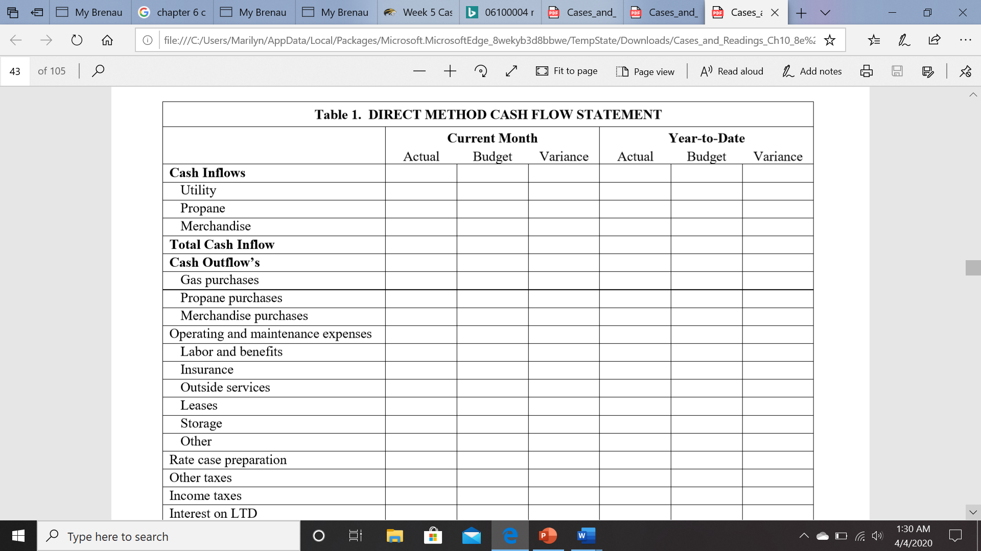

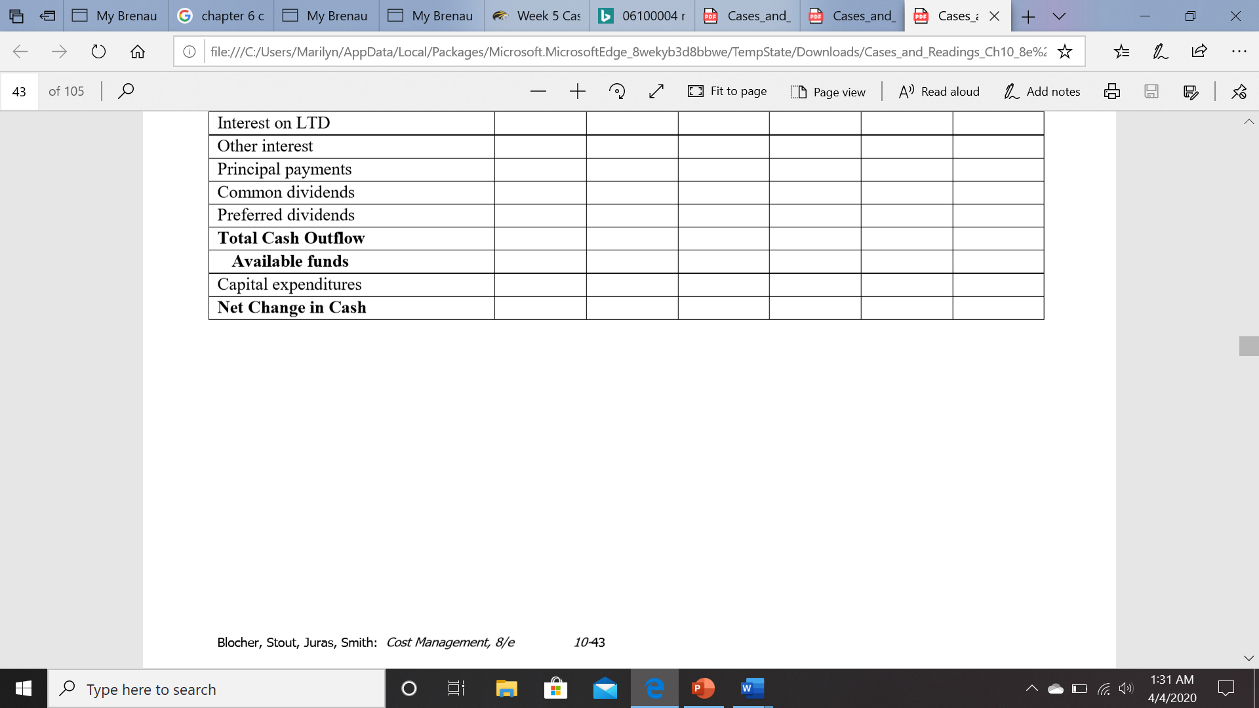

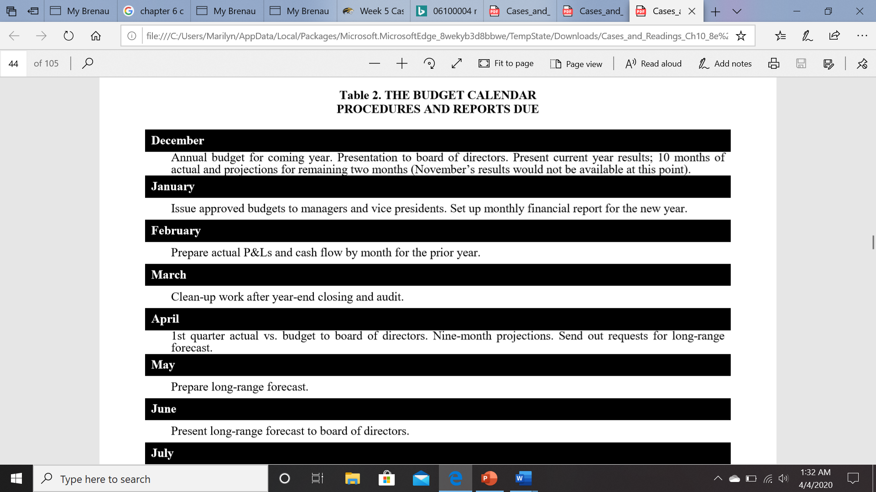

Answer Questions:
1. What motivates PFG to install a budgeting and planning system?
2. Why is flexibility very important for PFG’s budgeting system to be effective?
3. What problems that the budget manager at PFG had to resolve before setting up a budgeting system? Do you find these problems unique to PFG?
4. Why do the authors suggest that a thorough review of the firm’s chart of accounts, account classifications, and reporting systems are a must before initiating a budgeting and planning system?
5. Describe budgetary games that people play. What are the reasons for PFG to experience minimal budgetary gamesmanship?

